20250211 Pflichtaufgabe

## Aufgabe 1

Try to predict the exception, and write a short explanation.

1.1

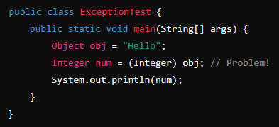

**What exception is thrown and why?**

ClassCastException because the program tries to cast a String into an Integer. That is not possible ant that is why a ClassCastException is thrown.

1.2

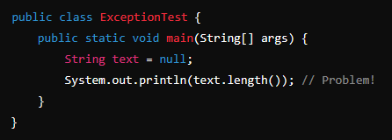

**What exception is thrown and why?**

NullpointerException, because the we try to call the length() method on a string object, but the String object is null. So there will be a NullPointerException.

1.3

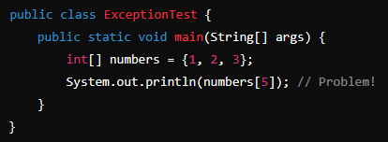

**What exception is thrown and why?**

ArrayIndexOutOfBounceException is thrown because we try to access the sixth element of the numbers array, but it has only three.

1.4

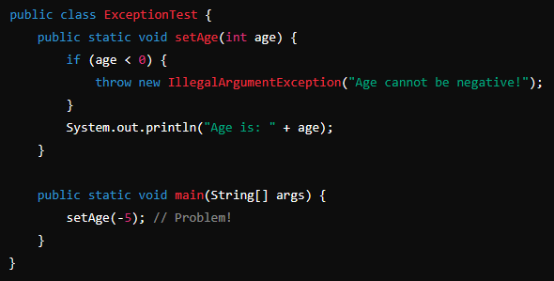

**What exception is thrown and why?**

A IllegalArgumentException is thrown because the setAge method is thowing that exception if the int age is below zero. We call that method with -5 and then the exception is thrown.

It has a customized message.

1.5

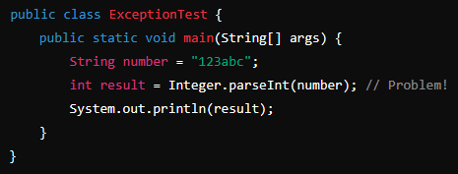

**What exception is thrown and why?**

This program will throw a NumberformatException because we try to parse a string into an integer but the string contains characters that are not numeric.

1.6

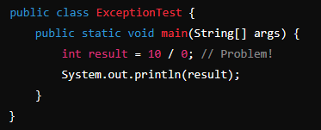

**What exception is thrown and why?**

ArithmeticException because we try to divide by zero.

1.7

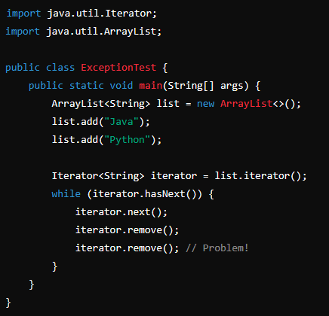

**What exception is thrown and why?**

This code causes a IllegalStateException because of the next remove method. It must follow a next method and in this case it is called two times but the element has already been removed.

1.8

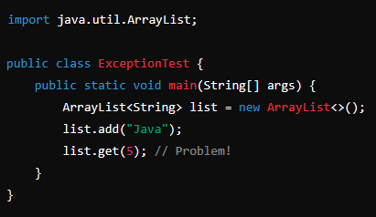

**What exception is thrown and why?**

The exception will be an IndexOutOfBoundsException because we try to get the element of the Arraylist with index 5 but it has only one element.

1.9

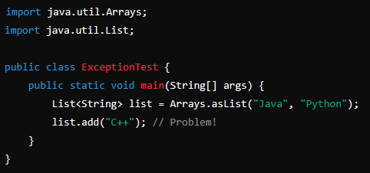

**What exception is thrown and why?**

UnsupportedOperationException will be thrown in that program because the list is initialized with an array. An array has a fixed size and is not meant to be extended. That is why the add method won’t work here.

1.10

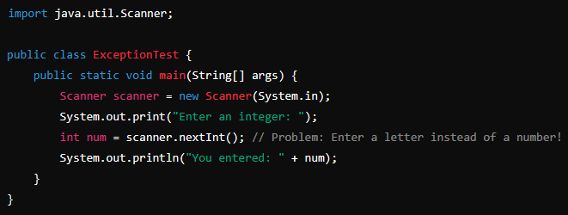

**What exception is thrown and why?**

InputMismatchException is thrown at this program. The nextInt method throws that exception when it fails while parsing the input into a int.

## Aufgabe 2

2.1 What is the difference between strong, weak, and soft references?

A strong reference is the most common use for objects. It indicates that a object is alive and is used by the program. As long as the reference points to an object the garbage collector won’t delete the object.

The weak reference doesn’t prevent the garbage collector from collecting an object.

A soft reference is like a weak one, but the garbage collector will only collect the object if necessary. Maybe the system is running low on memory.

2.2 How can you suggest Garbage Collection in Java?

It is possible to suggest garbage collection with *System.gc()*  but it is not guaranteed that the JVM will do it immediately.

2.3 What is the purpose of Garbage Collection in Java?

The main purpose of the garbage collector is to manage the system memory. It will reclaim the memory used by objects that aren’t used anymore. The programmer doesn’t have to do that manually.

2.4 What is the difference between checked and unchecked exceptions?

A checked exception is checked at compile time. When a checked exception is not handled by the code the program will not compile.

An unchecked exception is not checked at compile time. It can be handled by a try catch block as the checked exception too, but it doesn’t has to. When an unchecked exception is thrown and is not handled it causes the stop of the program.

2.5 What happens if an exception is thrown in a finally block?

It is not good practice to throw an exception in a finally block, because it overrides all exceptions in the try and catch blocks, if they exist. These exceptions are suppressed, and they will not be handled.

## Aufgabe 3

Fill in the Table with checked and unchecked Exceptions

|  |  |  |
| --- | --- | --- |
| Exception | Type | Short Description |
| IOException | checked | General I/O failure (e.g., file not found, read error). |
| ClassNotFoundException | checked | Thrown when an application tries to load class, that is not available |
| FileNotFoundException | checked | Signals that a file was not found |
| NoSuchMethodException | checked | when we try to call an unavailable method |
| NoSuchFieldException | checked | when a field cannot be found |
| NullPointerException | unchecked | Is thrown when we try to use a null reference  eg. null.size(); |
| ArrayIndexOutOfBoundsException | unchecked | If we try to access an element in an array.  eg. Array[5] but length = 2 |
| ArithmeticException | unchecked | Mathematical errors like division by zero |
| ClassCastException | unchecked | When we try to cast an object to another class which it is not an instance |
| InputMismatchException | unchecked | when we input a string when the scanner expects an int |

## Aufgabe 4

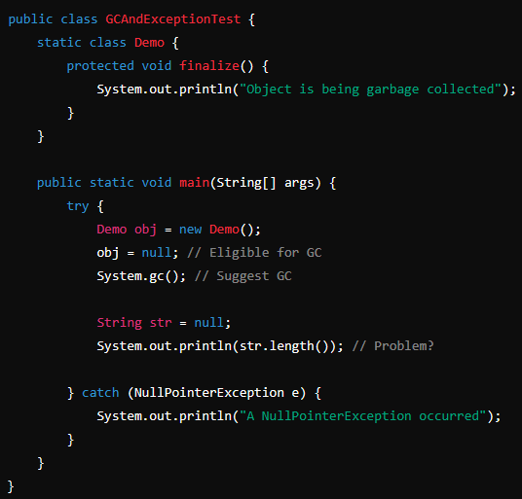

**4.1 What will be the output?**

A) "Object is being garbage collected"

B) "A NullPointerException occurred"

C) Both A and B (Order may vary)

D) No output

Answer: C

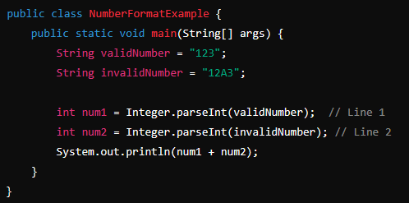

**4.2 Which line in the following code will throw a NumberFormatException?**

A) Line 1

B) Line 2

C) Both Line 1 and Line 2

D) No Exception

Answer: B

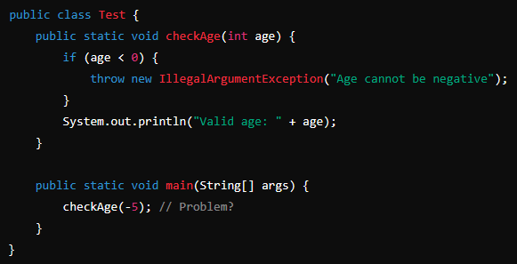

**4.3 What will happen?**

A) Prints "Valid age: -5"

B) Throws IllegalArgumentException with message "Age cannot be negative"

C) Compilation error

D) Prints "Valid age: 0"

Answer: B

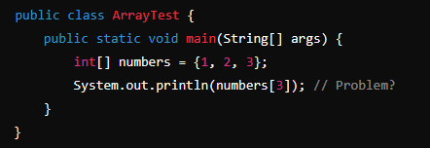

**4.4 What happens when the following code is executed?**

A) Prints 3

B) Prints 0

C) Throws **ArrayIndexOutOfBoundsException**

D) Compilation error

Answer: C

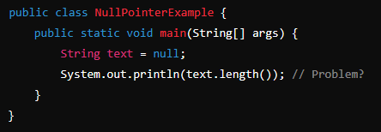

**4.5 The following program throws a NullPointerException. How can you fix it?**

A) Replace null with "Hello"

B) Use if (text != null) before accessing length()

C) Surround with try-catch

D) All of the above

Answer: D

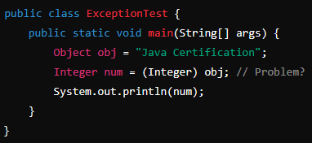

**4.6 What happens when the following code runs?**

A) Prints "Java Certification"

B) Prints null

C) Throws **ClassCastException** at runtime

D) Compiles successfully and runs without error

Answer: C